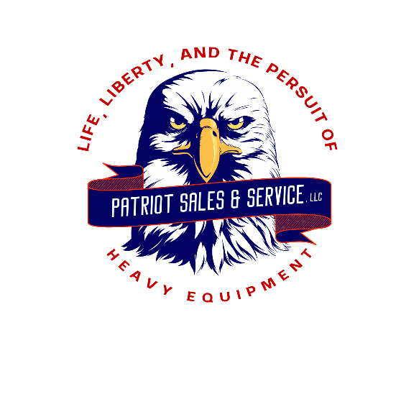

PHONE: 304-325-7323 FAX: 304-325-6525

WEBSITE: [WWW.RITCHIEEQUIPMENT.COM](http://WWW.RITCHIEEQUIPMENT.COM)

EMAIL: [PATRIOTEQUIPSALES@OUTLOOK.COM](mailto:PATRIOTEQUIPSALES@OUTLOOK.COM)

PATRIOT SALES & SERVICE, LLC

1244 MERCER MALL ROAD BLUEFILED, WV 24701

**2006 CAT 740 6X6 ARTICULATING TRUCK $87,500.00**

**S/N CAT00740CB1R01049**

**HOUR METER: 25,630**

**40 TON CAPACITY**

**AUTO TRANSMISSION**

**RETARDER**

**AIR RIDE**

**BED GOOD CONDITION**

**TOP BED RAILS REINFORCED / CAPPED**

**TIRES: 29.5 R25**

* **RF TITAN STL3 APPROX. 65%**
* **LF TITAN STL3 APPROX. 70%**
* **RRF MICHELIN XADN+ APPROX. 25%**
* **RRR ADVANTAGE GLRO2 APPROX. 25%**
* **LRF BRIDGESTONE VIT APPROX. 40%**
* **LRR MICHELIN XADN+ APPROX. 40%**

**FRESH PAINT**

**FULL SERVICE**

**WORK READY**

**GOOD CONDITION**

**FOR MORE INFORMATION AND TO VIEW EQUIPMENT, PLEASE VISIT** [**WWW.RITCHIEEQUIPMENT.COM**](http://WWW.RITCHIEEQUIPMENT.COM) **\*PRICES AND SPECIFICATIONS ARE SUBJECT TO CHANGE WITHOUT NOTICE\***