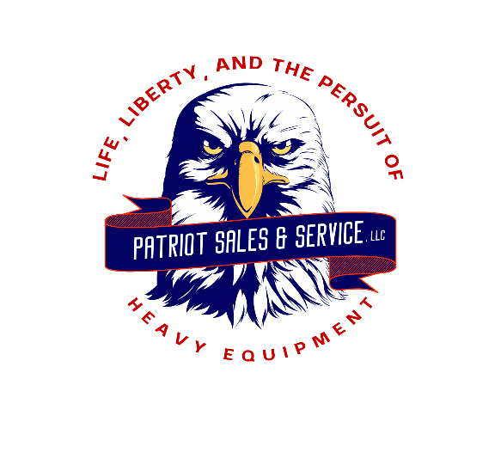

PHONE: 304-325-7323 FAX: 304-325-6525

WEBSITE: [WWW.RITCHIEEQUIPMENT.COM](http://WWW.RITCHIEEQUIPMENT.COM)

EMAIL: [PATRIOTEQUIPSALES@OUTLOOK.COM](mailto:PATRIOTEQUIPSALES@OUTLOOK.COM)

PATRIOT SALES & SERVICE, LLC

1244 MERCER MALL ROAD BLUEFILED, WV 24701

**2012 INTERNATIONAL 4400 MECHANICS TRUCK $55.000.00**

**S/N 1HTMKAAN6CH610442**

**MILES: 125,180**

**HOURS: 8756**

**MAXX FORCE DT ENGINE MODEL#A300**

* **300 HP**
* **ENGINE BRAKE**

**ALLISON 3000 AUTOMATIC TRANSMISSION**

**GVWR: 33,000#**

* **12,000# FRONT AXLE**
* **21,000# REAR AXLE**

**SPRING SUSPENSION**

**160’ WHEEL BASE**

**CHELSEA P.T.O.**

**13’6” TOOL BODY**

**IMT 5020 HYDRAULIC CRANE**

* **8600# LIFTING CAPACITY**
* **20’6” HORIZONTAL REACH**
* **3 SECTION BOOM**
* **HYDRAULIC OUTRIGGERS**
* **WIRED REMOTE**

**IMT CAS3560 HYDRAULIC AIR COMPRESSOR**

* **ROTARY**
* **60 CFM @ 150 PSI**
* **HOSE REEL**

**ALUMINUM WHEELS**

**TIRES: 11R 22.5**

* **R.F GENERAL AMERI-STEEL S 360 NEW**
* **L.F. GENERAL AMERI-STEEL S 360 NEW**
* **RRI ROAD X CD 885-R3 NEW**
* **RRO ROAD X CD 885-R3 NEW**
* **LRI ROAD X CD 885-R3 NEW**
* **LRO ROAD X CD 885-R3 NEW**

**EXTERIOR GAS CYLINDER RACK**

**HITCH RECEIVER**

**BUMPER VISE**

**STROBE/ BEACON LIGHT**

**GOOD CONDITION**

**FOR MORE INFORMATION AND TO VIEW EQUIPMENT, PLEASE VISIT** [**WWW.RITCHIEEQUIPMENT.COM**](http://WWW.RITCHIEEQUIPMENT.COM) **\*PRICES AND SPECIFICATIONS ARE SUBJECT TO CHANGE WITHOUT NOTICE\***